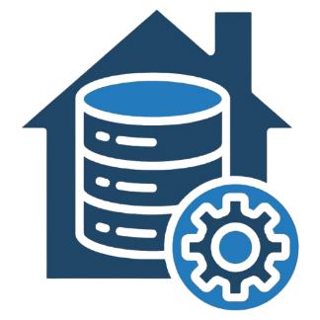

**Tools:** Power BI / Excel.

**Purpose:**

Create **interactive dashboards & reports**.

Provide **visual insights** (e.g., revenue trends, customer behavior).

Enable self-service analytics for business users.

**BI Layer**

**Storage:** SQL Server Analysis Services (SSAS).

**Purpose:**

Create pre-aggregated, fast-querying cubes and Enable drill-down, slicing, and dicing of data (e.g., sales by region, by year).

**OLAP Cube**

**Schema:** **Star Schema** (Fact & Dimension tables).

**Tables:**

**Fact Table:** FactSales (aggregated sales data from Orders and OrderRows).

**Dimension Tables:**

DimCustomer (from ConCustomer)

DimProduct (from ConProduct)

DimStore (from ConStore)

DimGeoLocation (from GeoLocations)

DimDate (from ConDate)

**Data Warehouse**

**Tools:** SQL Server Integration Services (SSIS)

**Extract:** data from OLTP sources (SQL Server & flat files).

**Transform**:

Aggregate data for reporting (monthly sales totals). Convert formats (e.g., from text to structured tables).

**Load:** into the **Data Warehouse (DW)**.

**ETL**

**Purpose of these data sources is,** Capture transactional business data from various systems.

SQL Server Database (ConCustomer, ConStore, CurrencyExchange,OrderRows )

CSV & TXT files (ConProduct, Orders, GeoLocations )

**Data Sources**